MS Stream – Tip Sheet

What is MS Stream?

MS Stream is a Microsoft Office 365 application for publishing, organizing, sharing, and viewing videos within a company. Videos cannot be shared externally.

How to access MS Stream?

- To access MS Stream, log in to your email account at owa.michener.ca. Click the icon in the top left corner.
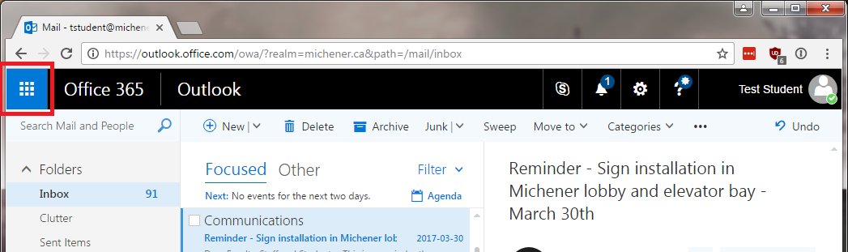

- A sidebar will appear. Click the “Stream” icon highlighted in red here (if not visible, click “All apps” and scroll down the list to find “Stream”).
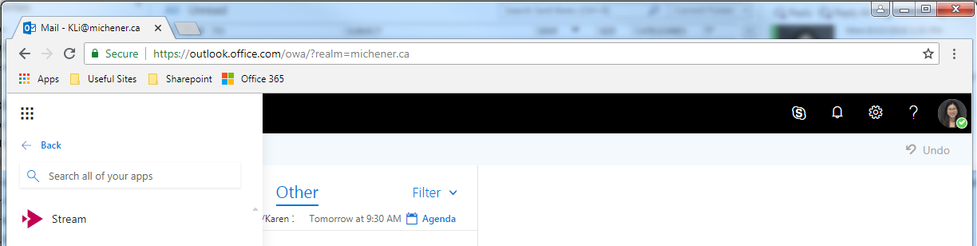

*TIP* You can pin MS Stream to the launcher for quick access by clicking the “…” for additional options.

Searching for Videos

The homepage of MS Stream features trending videos within the company, such as most watched videos.

There are numerous ways to complete a deeper search for videos:
- Search bar to search for all content that have been granted permissions to the user. User can search for any topic, user, or channel.
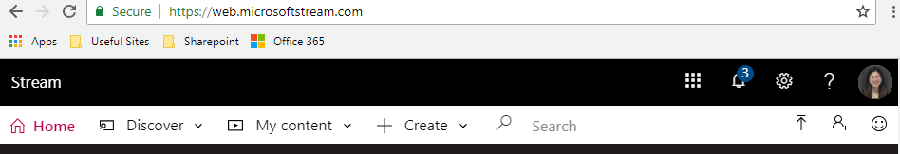

- “Discover” dropdown allows user to search by Videos, Channels, People, or Groups.
Note: Searching within a Groups page restricts the search to videos within the group.
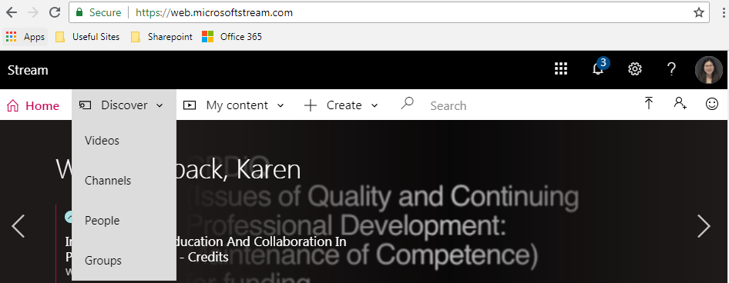

User can then sort to display the most relevant result.
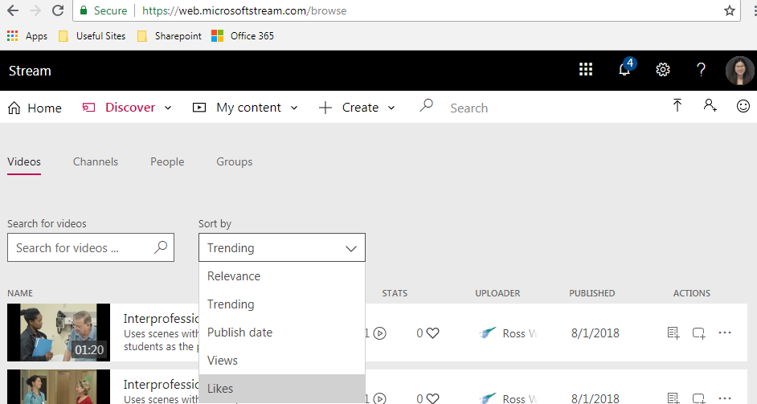

Sharing MS Stream Videos

MS Stream allows user to share videos within the company by the following methods:
- Share by URL link
- Share by E-mail
- Share by Embedding
Note: When you embed videos in other MS Apps, the permission will be retained and only permitted individuals will be able to view the video e.g. Yammer, Sharepoint, Teams.

Click the “Share” button for the MS Stream video.

Toggle between the tabs at the top to share by URL, E-mail, or embedding in other applications.
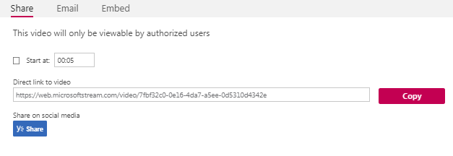
*TIP* Using the “Start at: ___” function, you can share videos to start at an exact time point in the video so the recipient does not have to navigate within the video.

