MS Stream – Tip Sheet

How to upload videos to MS Stream?

There are couple ways to upload videos to MS Stream.
*TIP* Multiple videos can be uploaded at a time.

Option 1 – In the MS Stream main toolbar, click the “Create” dropdown > Upload video or click the upload icon in the top right corner, then drag/drop or select video(s) to upload.
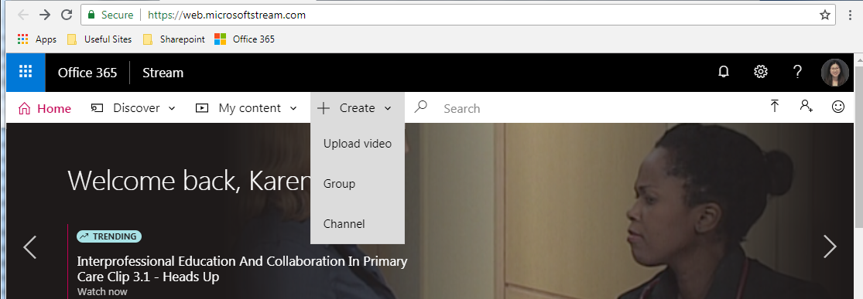

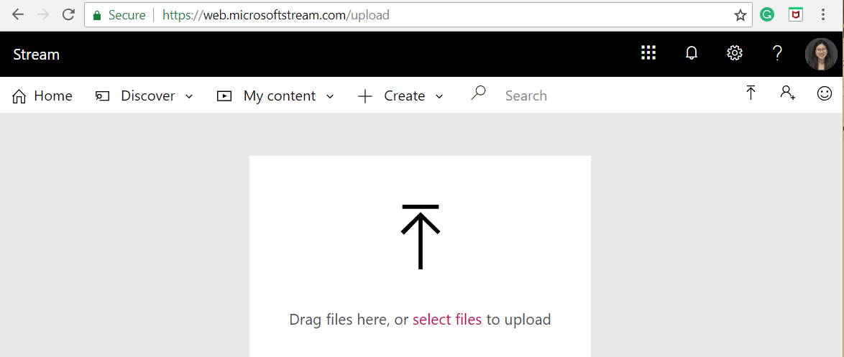

Option 2 – Within an existing MS Stream Channel or Group, click “Upload video” in the top right corner or drag/drop video(s) directly onto the page.
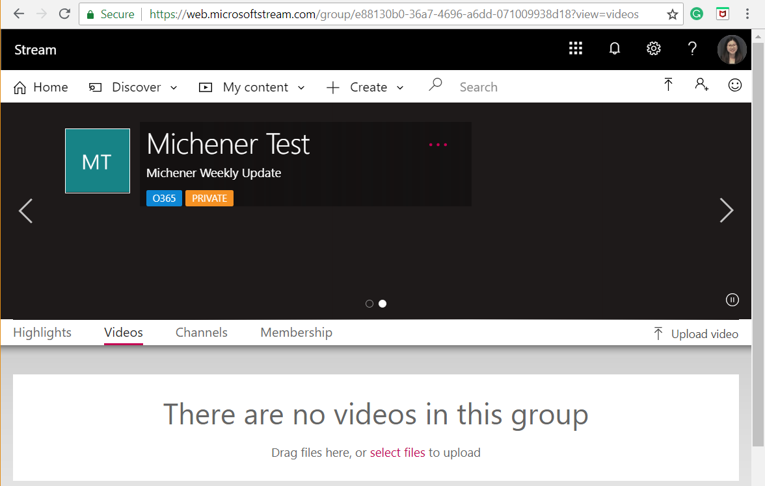

How to set up video metadata?

MS Steam video is given a title and description to provide viewers context for the video, and to allow simple search of videos for users.

Note: Video title, description, and closed captions (if turned on) are searchable.

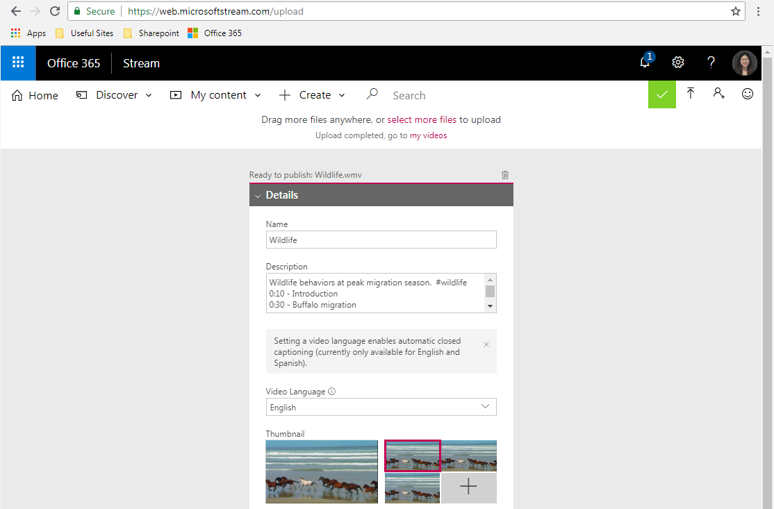
Set a video language to enable auto-generated closed captioning (currently available in English and Spanish); this provides another way for users to discover the video based on the transcribed text.

Video Descriptions is a free text box to provide additional details about the video, and can contain interactive elements such as:
- Time codes (H:MM:SS) - You can build an interactive table of contents for the video by typing in the time codes of interesting points in the video. Viewers will be able to click on these time codes to jump to that point of the video.
- #Hashtags - Add #hashtags to your video description to group similar videos together. Viewers will be able to click on the #hashtags and see other videos with the same tag.
Video Descriptions has a 4000 characters limit.

Video Name/Title has a 30 characters limit.

Select the thumbnail to represent the video.

Setting Video Permissions
(Review section for “Video Organization & Permissions - Channels vs. Groups)

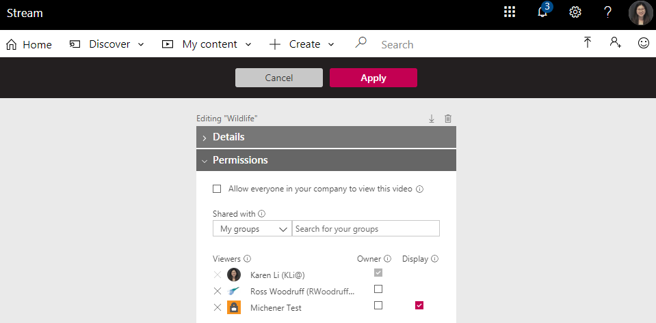
Control the Owner and Display setting of the video.

Owner – When checked, corresponding individual(s) can view, edit information about the video, change who can access the video, change settings of the video/group, delete the video, and download the original video. If you make a Microsoft Stream group an owner, you’re allowing the contributors of that group to edit information about your video and change who can access it.

Display – When checked, video will be displayed on the corresponding Microsoft Stream group’s page (this can only be set for the MS Stream group you have permissions to contribute videos to)

- Owner – When checked, corresponding individual(s) can view, edit information about the video, change who can access the video, change settings of the video/group, delete the video, and download the original video.
If you make a Microsoft Stream group an owner, you’re allowing the contributors of that group to edit information about your video and change who can access it.
- Display – When checked, video will be displayed on the corresponding Microsoft Stream group’s page (this can only be set for the MS Stream group you have permissions to contribute videos to).

Search for the Channel, Group, and/or People the video should be shared with.
When checked, everyone in the company can view this video, and add it to their groups and channels.

*TIP* If a large group of people require access to the view the video, contact Helpdesk to create an Active Directory list to avoid manual addition of each person. Example: Contact Helpdesk to create an Active Directory of all 1st year students in the Medical Laboratory Services program so they can view a specific MS Stream video/group.

Setting Additional Video Options

MS Stream will generate facial recognition and auto-closed captions for an interactive experience. Users can also enable comments to allow anyone who watches the video to comment. Additional setting for closed captions is also found here:

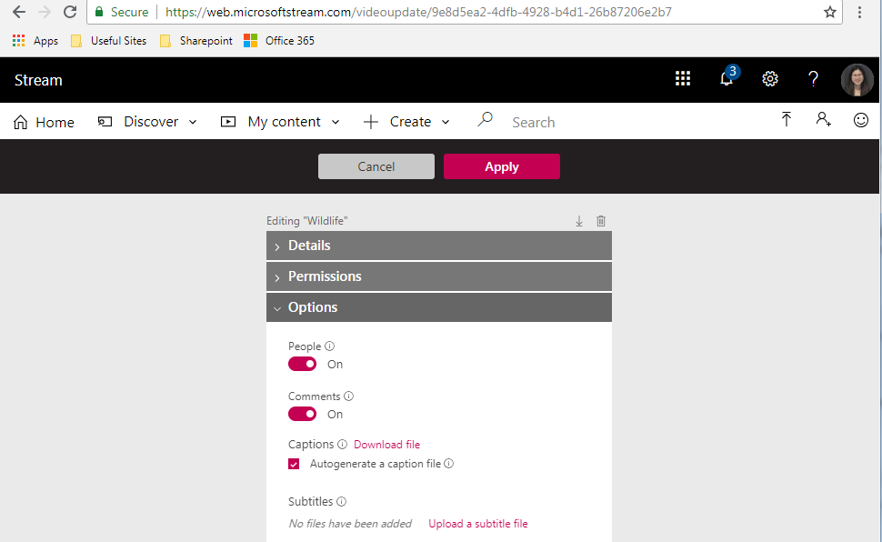
Alternatively, owner can upload their own subtitle file.
If checked, MS Stream will auto-generate a closed caption file based on the language selected in the Details section. The auto-generated closed captions file can be downloaded for further editing.
If on, viewers can leave comments.
If on, MS Stream will generate a timeline view of people in the video. Viewers can then jump to certain points in the video where the person appears.

Video Organization & Permissions - Channels vs. Groups

MS Stream provides two main organizational methods for uploaded videos:

- Companywide Channels is used to organize videos into a common subject, however it does not offer a permission method. Anyone in the company can add/remove videos from the channel.
*TIP* For this reason, it is not recommended to create companywide channels. Groups and Channels within a Group should be used instead, see method 2 below.

- Groups is be used to organize videos and to control access to videos by defining a set of owners and members within the group. Groups can be made public for everyone to view or private for selected individuals to view.
Channels created within Groups is a second-level organizational method (example: Videos in the “AV” Group can be sub-organized into channels for respiratory, radiological technology, etc.); Channels within Groups will inherit the permission and access settings of the parent Group.
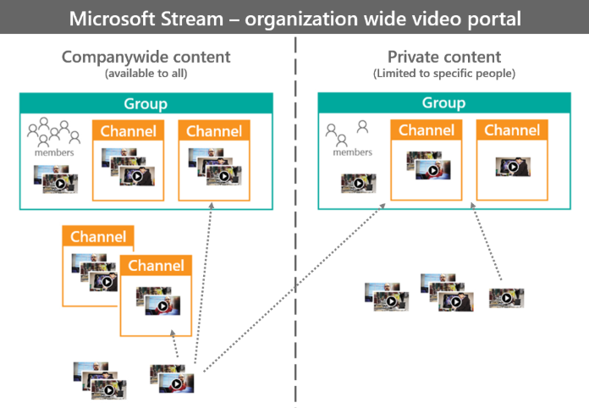

Scenarios for Companywide Channels vs. Groups
Organization Method | Characteristics | Setup selection
Companywide Channel | - Everyone in the company can see videos in this channel  - Everyone in the company can add and remove videos to this channel. *Reminder Tip* For this reason, it is not recommended to create a companywide channel. Groups or Channels within Groups should be used instead.  - Only videos with "Allow everyone in your company to view this video" checked can be added to this channel  - No 2nd level organization of videos within this channel | In the MS Stream main toolbar, click “Create” dropdown and select “Channel”.  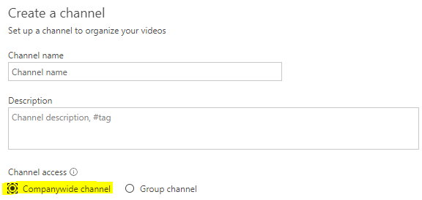
Companywide/Public Group  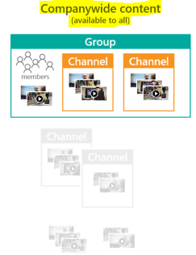 | - Everyone in the company can see videos in this group (regardless if they've joined the group or not)  - Anyone can join this group  - Group Owners can upload/edit videos  - Group Members can also be assigned to upload/edit videos  - Owners or Members with contributor access can further organize videos by adding channels within the group | In the MS Stream main toolbar, click “Create” dropdown and select “Group”:  - Select “Public Group” for Access  - Allow all members to contribute,  - If on, all members can add and remove videos and channels, and edit the permissions and metadata of videos in this group  - If off, all members can only view the videos  3) Under Add group members, additional owners can be assigned.  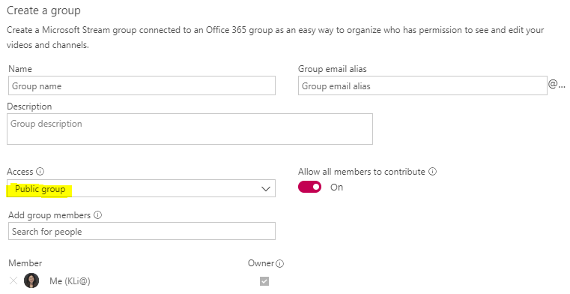
Private Group  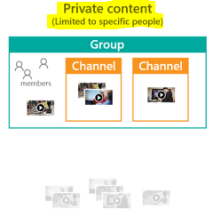 | - Only owners and members of the group can see videos in this group  - Group Owners can upload/edit videos, and have to approve addition of new members to the group  - Group Members can also be given permission to upload/edit videos  - Owners or Members with contributor access can further organize videos by adding channels within the group | In the MS Stream main toolbar, click “Create” dropdown and select “Group”:  - Select “Private Group” for Access  - Allow all members to contribute,  - If on, selected members can add and remove videos and channels, and edit the permissions and metadata of videos in this group  - If off, selected members can only view the videos  - Under Add group members, additional owners and members can be assigned. The group will only to visible to these individuals.  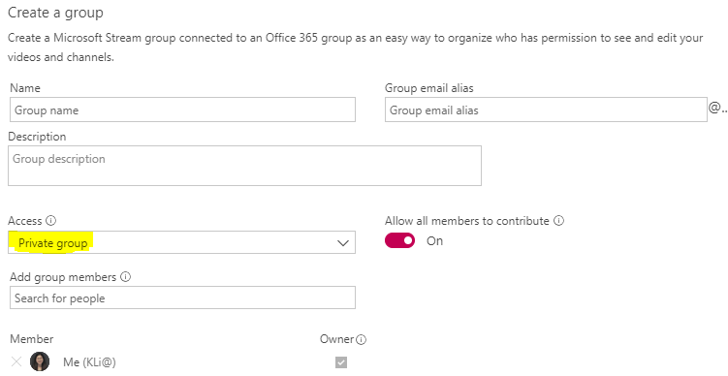

Revising Settings of Uploaded Videos

If you have Owner permission of the uploaded video or an existing group or channel, settings can be edited by going to “My Content” dropdown, and select Videos, Groups, Channels as applicable.

*TIP* If you are the assigned owner of a video, you can download the original video format/size for further editing.

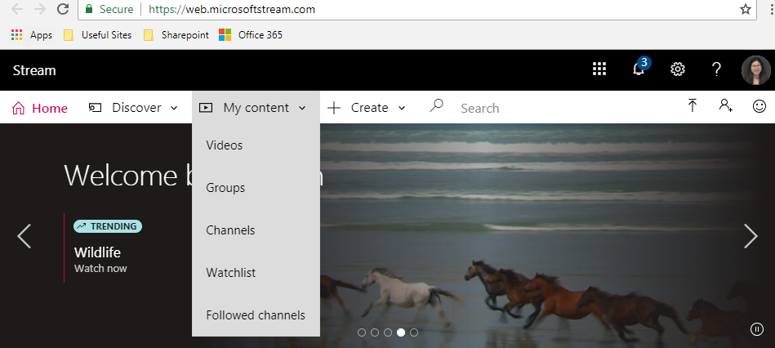

If editing settings of a specific video, click the “…” and select “Edit” or “Download original video” for further editing.

If editing settings of a Group or Channel, click the “…” of the group/channel and select “Edit”.

